Abhishek Niwalkar
abhishekniwalkar543@gmail.com
Abstract
In order to produce actionable insights for strategic business growth, this project uses Power BI to analyze Myntra's sales, product, and customer data.
Myntra Anual Sales Analysis Report
A Comprehensive Power BI–Based Study on Sales Trends and Strategic Growth Opportunities
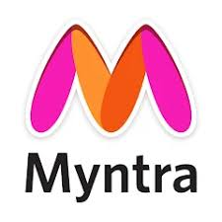
TABLE OF CONTENTS

INTRODUCTION 2
BUSINESS OBJECTIVE 2
PROBLEM STATEMENT 2
DATA EXPLORATION 3
SOLUTION APPROACH 4
DATA MODELLING 5
DASHBOARD 6
FEATURES OF THE DASHBOARD 7
VISUAL COMPONENTS CREATED 8
BUSINESS OUTCOMES 13
CONCLUSION 14
FUTURE SCOPE 14

INTRODUCTION
The Myntra Sales Data Visualization Project uses Microsoft Power BI to turn unstructured e-commerce data into strategic business insights. The dashboard offers a thorough analysis of Myntra's yearly performance by combining sales, product, and customer datasets into a star schema model. Important indicators that aid in assessing operational effectiveness and profitability include total revenue, orders, product count, and discount rates. The dashboard examines trends across brands, categories, and geographical areas using interactive visualizations and DAX measures. From a business perspective, it facilitates data-driven decision-making, which helps Myntra find growth prospects, enhance marketing efficacy, and optimize pricing strategies. By bridging the gap between strategy and analytics, this project enables Myntra to use actionable insights to improve customer satisfaction and revenue

BUSINESS OBJECTIVE
To optimizing the product portfolio, pricing, and discount strategies, the company's primary goal is to achieve sustainable revenue growth and profitability. Through strategic insights into sales performance, consumer behavior, and brand competitiveness across various categories and regions, it aims to improve operational efficiency, increase market penetration, and improve customer satisfaction.

PROBLEM STATEMENT
Understanding market and category performance, identifying key revenue drivers, optimizing pricing and discount strategies, and supporting data-driven business decisions for increased profitability and growth are all part of the project's scope.

DATA EXPLORATION
The data was sourced from an Excel workbook containing three worksheets.

Worksheet 1: dim_products
Column Name | Description
Product_ID | Unique ID for each product
Category | Product category (Men, Women, Kids, Beauty)
Sub_Category | Specific sub-category (Jeans, Tops, Shoes,etc.)
Product_Name | Name of the product
Brand_Name | Brand of the product
Size | Product size (S, M, L, XL)
Colour | Product color
Ratings | Customer rating for the product

Worksheet 2: dim_customers
Column Name | Description
Customer_ID | Unique ID for each customer
Customer_Age | Age of the customer
City | Customer’s city
State | Customer’s state

Worksheet 3: fact_orders
Column Name | Description
Order_ID | Unique identifier for each order
Customer_ID | Foreign key linking to dim_customers
Product_ID | Foreign key linking to dim_products
Date | Order date
Original_Price | Listed price before discount
Discount | Discount applied on product
Final_Price | Price after discount

SOLUTION APPROACH
Creating new measures to calculate key performance indicators
Measure Name | Formula (DAX) | Description
Total Orders | Total_Orders = DISTINCTCOUNT(fact_orders[Order ID]) | Counts unique order IDs to get total orders placed.
Total Sales Amount | Total_Sales_Amount = SUM(fact_orders[Sales Amount]) | Total sales generated after discount.
Total Revenue | Total_Revenue = SUMX(fact_orders, fact_orders[Original Price] * (1 - fact_orders[Discount%]/100)) | Calculates total revenue before additional expenses.
Average Sales Amount | Avg_Sales_Amount = AVERAGE(fact_orders[Sales Amount]) | Calculates mean sales amount per order.
Average Discount | Avg_Discount = AVERAGE(fact_orders[Discount%]) | Measures the average discount percentage across orders.
Sum Original Price | Sum_Original_Price = SUM(fact_orders[Original Price]) | Total sum of original product prices before discounts.
Product Count | Product_Count = DISTINCTCOUNT(dim_products[Product ID]) | Counts the number of unique products listed.
Avg Original Price | Avg_Original_Price = AVERAGE(fact_orders[Original Price]) | Finds average product price before discounts.
Avg Ratings | Avg_Ratings = AVERAGE(dim_products[Ratings]) | Determines the overall average rating of products.

DATA MODELLING
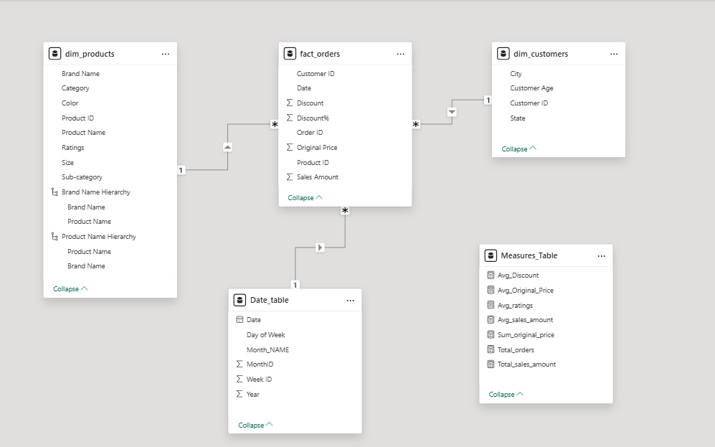

DASHBOARD
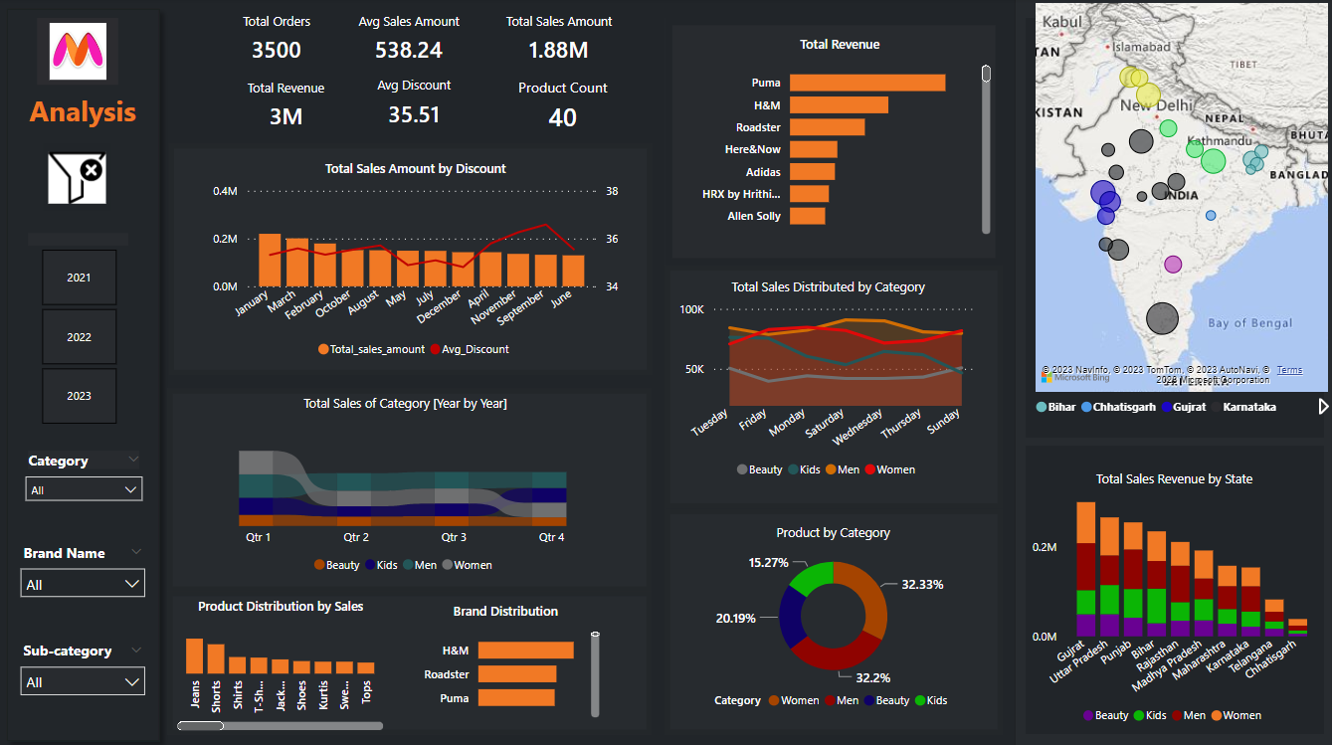

FEATURES OF THE DASHBOARD

Key Performance Indicators (KPIs) included:
KPI | Formula | Columns Used | Result | Purpose
Total Orders | COUNT(Order ID) | Order ID | 3,500 | Total transaction volume
Average Sales Amount | SUM(Sales Amount) / COUNT(Order ID) | Sales Amount, Order ID | 538.24 | Average revenue per order
Total Sales Amount | SUM(Sales Amount) | Sales Amount | 1.88M | Gross sales value
Total Revenue | SUM(Sales Amount) - SUM(Discount Value) | Sales Amount, Discount | 3M | Earnings after discounts
Average Discount | AVERAGE(Discount %) | Discount % | 35.51% | Mean discount offered
Product Count | COUNTDISTINCT(Product Name) | Product Name | 40 | Unique product variety
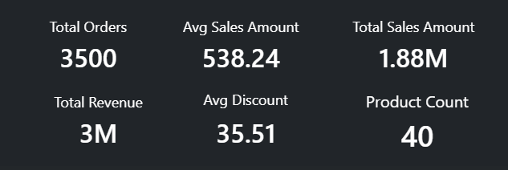

VISUAL COMPONENTS CREATED
Total Sales Amount by Discount
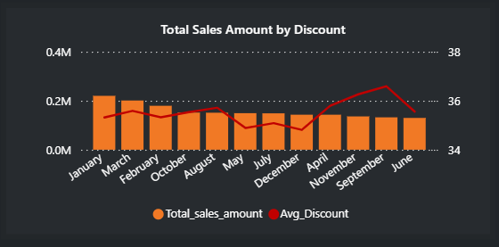
In order to help Myntra improve pricing and promotional tactics for greater profitability, the graph, which compares monthly sales to average discounts, shows that moderate discounts increase sales while excessive discounts have little effect.

Total Sales of Category (Year by Year)
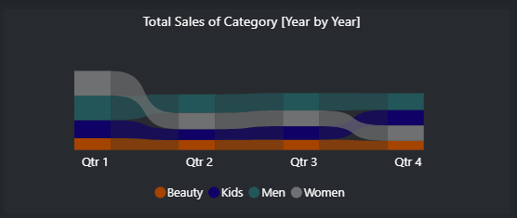
The graph, which contrasts sales by category over the course of several quarters, demonstrates that Myntra consistently performs well in its core fashion segments, with the Women and Men categories leading and the Kids and Beauty categories remaining stable.

Product Distribution by Sales
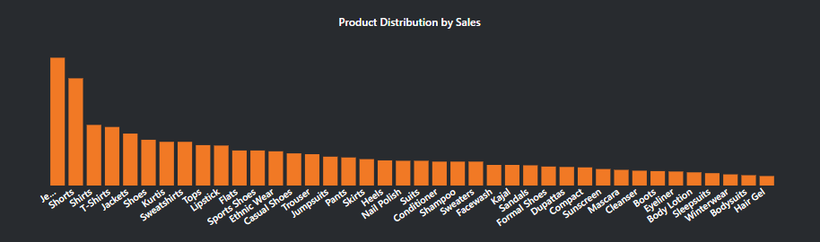
When compared to lower-selling beauty and accessory products, the chart illustrates how Myntra performs well in core apparel categories, with jeans, shirts, and t-shirts accounting for the majority of overall sales.
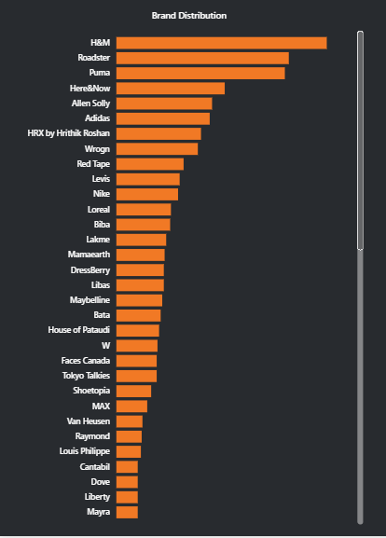
Total Revenue by Brand

The top-performing brands on Myntra are H&M, Roadster, and Puma, according to the brand-wise sales distribution chart. Across the main product categories, it shows a strong consumer preference for high-end and fashionable fashion labels.

Total Sales Distributed by Category
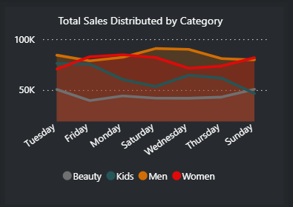
The top-performing brands on Myntra are H&M, Roadster, and Puma, according to the brand-wise sales distribution chart. Across the main product categories, it shows a strong consumer preference for high-end and fashionable fashion labels.

Product by Category (Pie Chart)
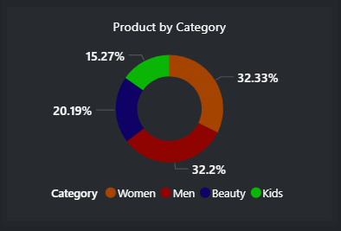
Product distribution by category is depicted in the chart. The market is dominated by women (32.33%) and men (32.2%), with beauty (20.19%) and children (15.27%) making up smaller but still significant product segments.

Sales by Geography (Map Visualization)
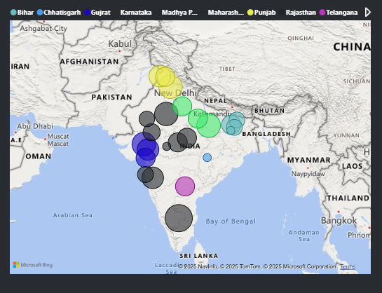
This map shows the distribution of Myntra's sales by state in India. While smaller clusters highlight emerging markets in other states, major sales concentrations in Karnataka, Maharashtra, Gujarat, and Delhi show a strong market presence in metropolitan and western regions.

Total Sales Revenue by State (Bar Chart)
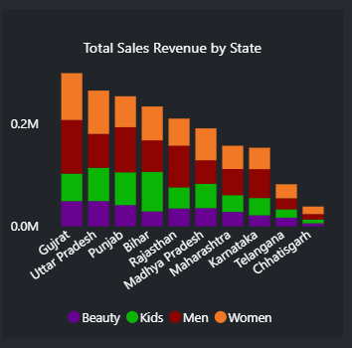
Gujarat and Uttar Pradesh are the top-performing states for Myntra, according to this chart, which breaks down total sales revenue by state. The categories with the highest overall revenue are men's and women's, with beauty and children's products making up a smaller portion.

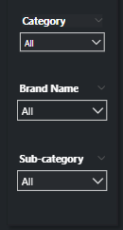
Interactive Slicers Added:
- Category
- Brand Name
- Sub-category
- Year (2021, 2022, 2023)
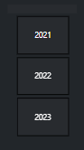

BUSINESS OUTCOMES
Findings and Insights:
- Top Brands: Puma, H&M, and Roadster have the highest combined revenue, which is a result of their appealing brands, steady demand, and successful cross-segment marketing tactics.
- Top Categories: About 32% of total sales come from women's products, demonstrating high customer engagement and Myntra's successful positioning in the female fashion market.
- Best-Performing Products: Across a range of age and gender groups, customers prefer essential, trend-driven clothing, with jeans, shirts, and t-shirts accounting for the majority of overall sales.
- Impact of the Discount: Optimal pricing greatly increases customer acquisition and profitability, as evidenced by the higher conversions and purchase volumes that moderate discounts of 30–40% generate.
- Geographical Insights: The highest revenue-generating states in northern and western India are Gujarat, Uttar Pradesh, and Punjab, which demonstrate robust market penetration and consumer responsiveness.
- Category Trends: Because of growing demand, a wide range of products, and successful marketing techniques, the women's category has been growing steadily year over year.
- Seasonal Trends: Q4 is Myntra's most profitable quarter, with record-breaking sales fueled by holiday promotions, year-end clearance sales, and festive seasons.

CONCLUSION
This dashboard provides a holistic view of Myntra’s annual sales performance. Key business opportunities for Myntra are identified by the analysis, which also highlights regional revenue concentration, discount optimization, and category-wise sales gaps. While underperforming markets like Kids and Beauty require targeted promotions, moderate discounts maximize sales. By utilizing these insights, Myntra can improve market reach, enhance pricing, and fortify data-driven decision-making for long-term growth in the fiercely competitive fashion e-commerce sector.
FUTURE SCOPE
- Incorporate real-time data refresh.
- Build a mobile-optimized version of the dashboard.

